Requirements/Design Specification

**Feb2015 GH322**

**Change Frequency of S/Q Items to per Occurrence**

**CR 13375**

Revision History

|  |  |  |  |
| --- | --- | --- | --- |
| **Date** | **Revision** | **Description** | **Author** |
| 2/2/2015 | 1.0 | Initial Version with Requirements | Roger Behm |
|  |  |  |  |
|  |  |  |  |
|  |  |  |  |
|  |  |  |  |

The information furnished herein by Republic Services Inc. is proprietary and confidential to Republic Services Inc. personnel and is not to be duplicated, published, or disclosed to any third party in whole or in part without permission from Republic Services, Inc.

© Copyright 2012, Republic Services Inc. - All rights reserved.

Table of contents

1 Business Requirements 6

1.1 Purpose of the Design Specification 6

1.1.1 Bug list for current release 6

2 Competitor Overview and Assumptions 6

3 Design 6

3.1 #322 Change Frequency of S/Q Items to per Occurrence 6

4 InfoPro Interface 8

5 Report Changes 8

6 Appendix 8

# Business Requirements

## Purpose of the Design Specification

This document highlights items to be fixed and implemented for the titled release.

### Bug list for current release

| GitHub Item  Number | **Description** |
| --- | --- |
| 322 | Change Frequency of S/Q Items to per Occurrence |

# Overview and Assumptions

Since the InfoPro upload does not take into account multiples of a type of service revenue such as Delivery, Capture line item detail for these need to be per service.

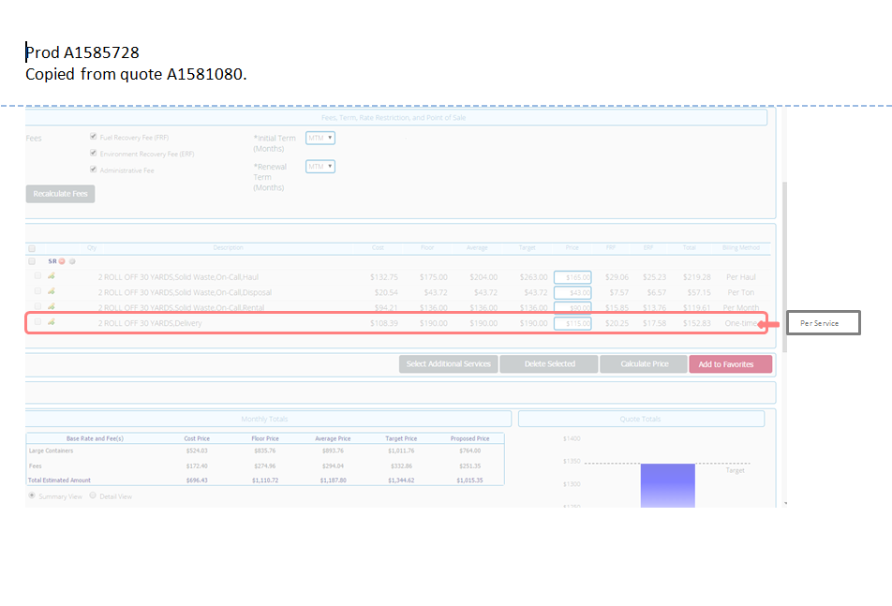

# Design

## #322 Change Frequency of S/Q Items to per Occurrence

Change the "One-Time" billing method to "Per Service” and correct the calculations for delivery and removal.

Create 5 new variables to store the one time charges, keeping the per service variables for InfoPro upload purposes and display new variables on the supporting documents (Proposal and CSA)

* deliveryChargeSubtotal_onetime_quote
* oneTime_valuedCustomerDiscount_quote
* exchangeChargeSubtotal_onetime_quote
* numberOfTotalRemovalContainers_quote
* oneTime_exchangeCustomerDiscount_quote

[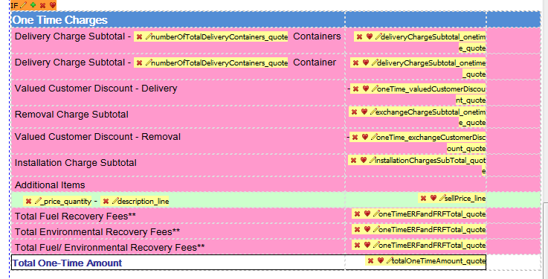](https://cloud.githubusercontent.com/assets/9746456/5859937/57f85304-a21b-11e4-929c-a1daa3906149.png)

[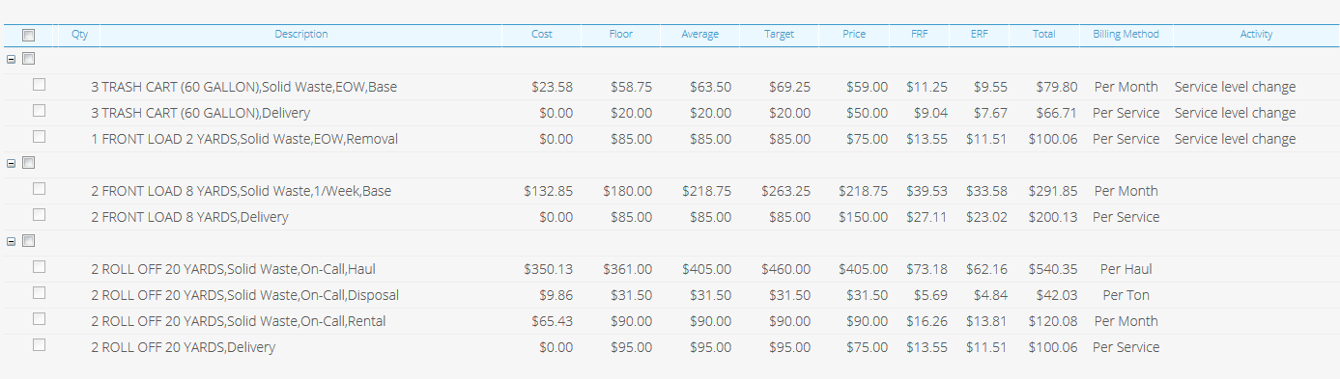](https://cloud.githubusercontent.com/assets/9746456/5860086/3b224522-a21c-11e4-8af6-2498263d0519.png)

[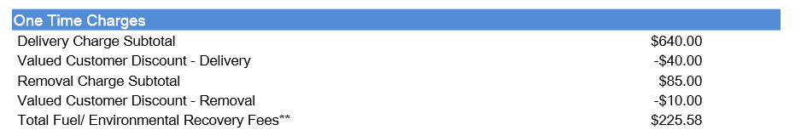](https://cloud.githubusercontent.com/assets/9746456/5860063/1d1c9a28-a21c-11e4-8c27-c2e0890d7cb1.png)  
[image](https://cloud.githubusercontent.com/assets/9746456/5860067/25ebde5c-a21c-11e4-8a27-8fb8f043fc32.png)

# InfoPro Interface

New variables (below) should not affect InfoPro AAE process but will include InfoPro team on testing.

* deliveryChargeSubtotal_onetime_quote
* oneTime_valuedCustomerDiscount_quote
* exchangeChargeSubtotal_onetime_quote
* numberOfTotalRemovalContainers_quote
* oneTime_exchangeCustomerDiscount_quote

# Report Changes

NA

# Appendix